|  |
| --- |
| aPPLICATION rOLE aDMINISTRATOR pORTAL AND rEPORTS |
| Date: 11/4/2022 |
| Author: CSD Identity Management |

Contents

gETTING sTARTED 3

aPPLICATION rOLE aDMINISTRATOR pORTAL 3

Creating a Role 4

Modifying a Role 5

Deleting a Role 7

Creating an Approver Group 9

rEPORTS 12

Generating Reports 12

Troubleshooting 15

# gETTING sTARTED

The purpose of this document is to provide instructions for how to add/modify/remove roles in the Application Role Administrator Portal and run Reports in SailPoint.

This guide will cover the following uses of the Application Role Administrator Portal and Reports functionality in SailPoint:

|  |  |
| --- | --- |
| **Application Role Administrator Portal** | **Reports** |
| * Create a New Role * Modify a Role * Remove a Role | * CBP Access Request Report * CBP Current Access Report * CBP Policy Violation Report * CBP Leaver Report * CBP Application Roles Report * CBP Login Activity Access Revoked Report * CBP Activity Monitoring Last Login Report * CBP Certification Report |

Users can access SailPoint using the following link: <https://cbpidentity.cbp.dhs.gov/identityiq>

# aPPLICATION rOLE aDMINISTRATOR pORTAL

The **Application Role Administrator Portal** allows users to create new roles, modify descriptions of existing roles, and delete current roles.

To access the **Application Role Administrator Portal**, users must have the **ICAM-ADMIN-PORTAL** role for the respective application and environment. Users can request access to this role through the **Request Access** tile.

* **Ex:** A user with the SPLUNK_PRD_ICAM-ADMIN-PORTAL role can access the Application Role Administrator Portal for the Splunk production environment

To navigate to the **Application Role Administrator Portal**

* Click on the **Application Role Administrator** tile on the SailPoint **Home Screen**

Or

* Click on the **Quick Links** menu in the upper left corner, select **My Tasks**, then **Application** **Role Administrator**.

The **Application Role Administrator** page will display, as shown below.

## Creating a Role

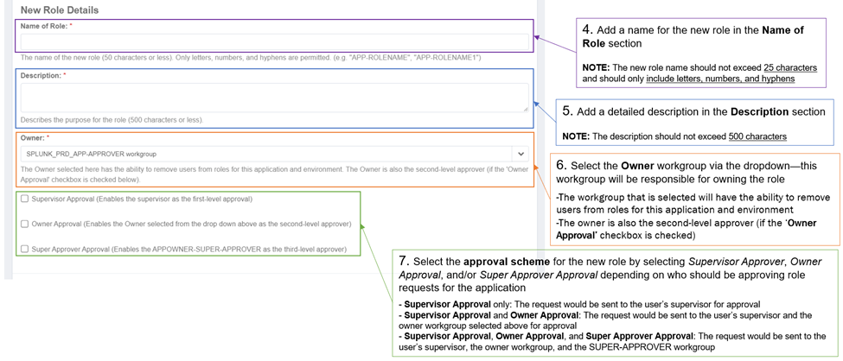

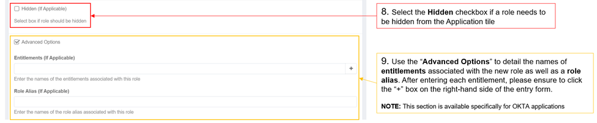

* In the **Change Summary**, you can see a summary of the new role that you are adding, including the **Role Name** that will appear for users to request. If you are satisfied with your new role, select **Submit**, otherwise cancel the request by selecting **Cancel**.

* Once you click Submit, you will be taken back to the Home Screen where you will see a green banner that your request has been submitted. You can also track this request in **Track My Requests**.

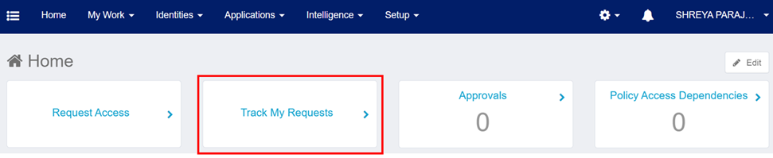

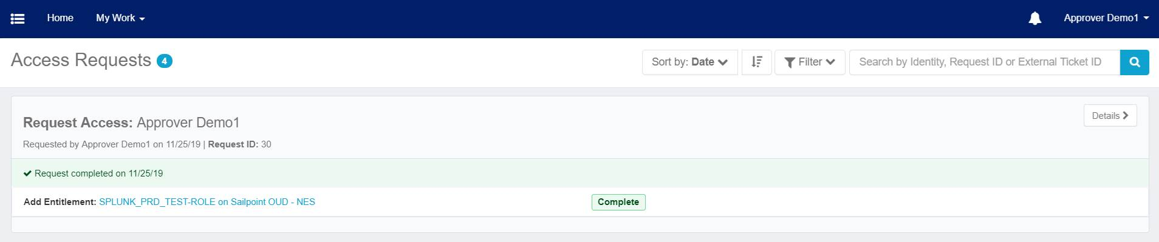

* An **Email Notification** with the details of the role creation will be sent to APP-APPROVER and SUPER-APPROVER for that environment and application.

## Modifying a Role

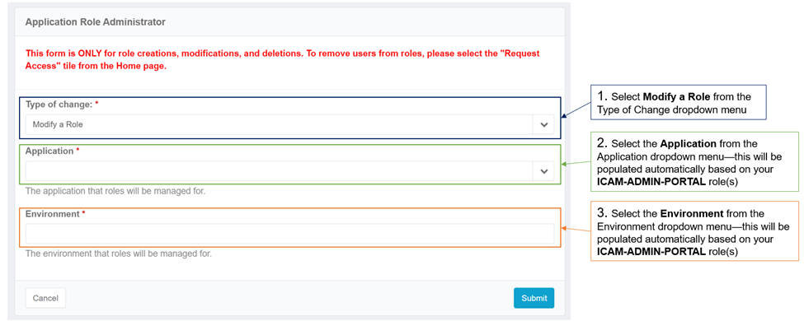

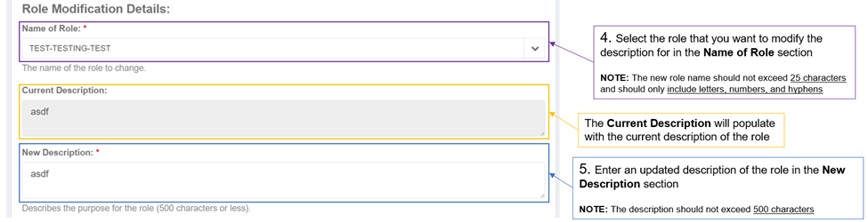

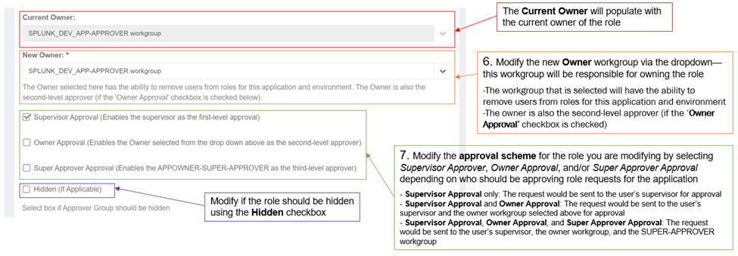

* In the **Change Summary**, you can see a summary of changes made. If you are satisfied with your changes, select **Submit**, otherwise cancel the request by selecting **Cancel**.

* Once you click Submit, you will be taken back to the Home Screen where you will see a green banner that your request has been submitted. You can also track this request in **Track My Requests**.



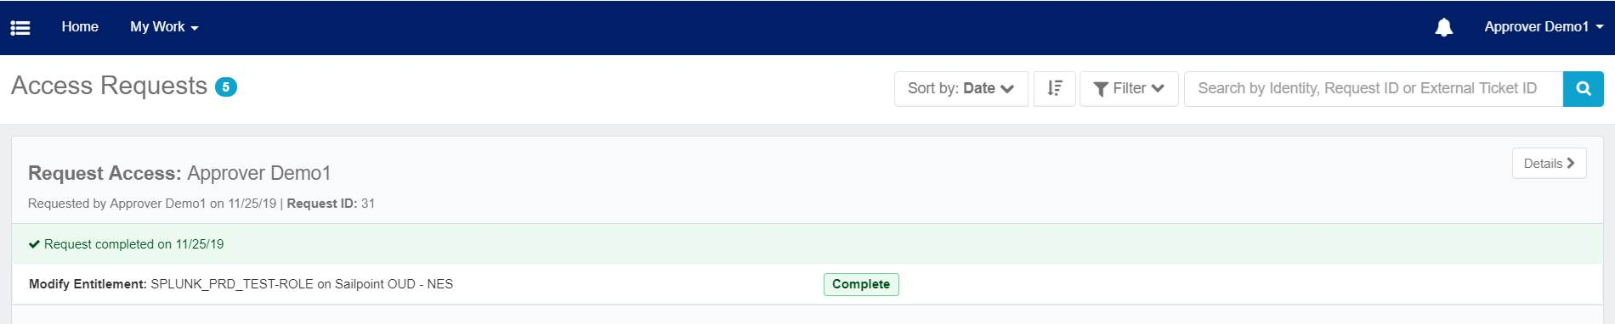

* An **Email Notification** with the details of the role modification will be sent to APP-APPROVER and SUPER-APPROVER for that environment and application.

## Deleting a Role

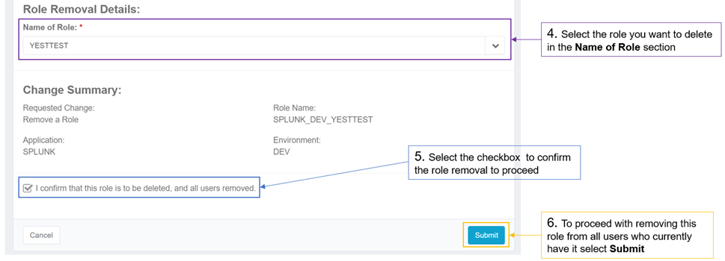

* Once you click Submit, you will be taken back to the Home Screen where you will see a green banner that your request has been submitted. You can also track this request in **Track My Requests**.



* If you select **Details** from the Access Requests screen, you can see which users had their access removed in the **Errors and Warnings** section.

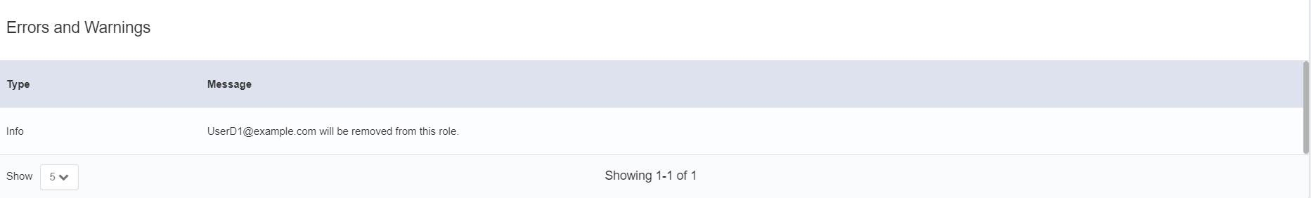

* An **Email Notification** with the details of the role removal will be sent to the APP-APPROVER and SUPER-APPROVER for that environment and application.

## Creating an Approver Group

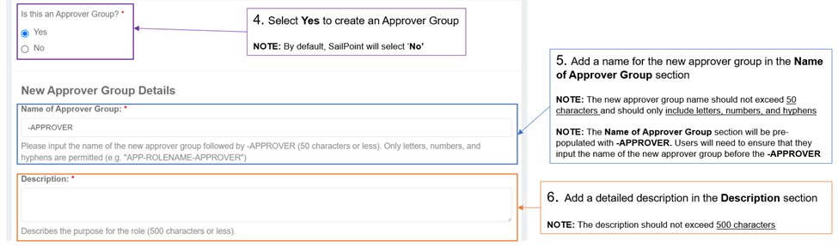

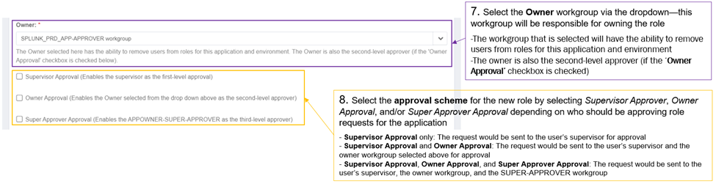

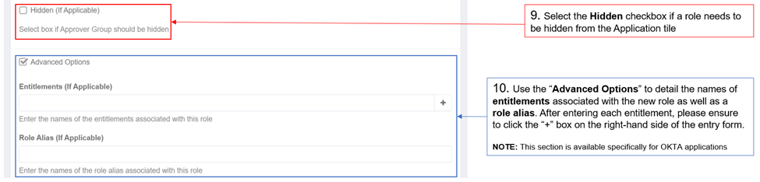

* In the **Change Summary**, you can see a summary of the new approver group that you are adding, including the **Approver Group Name** that will appear for users to request. If you are satisfied with your new approver group, select **Submit**, otherwise cancel the request by selecting **Cancel**.

* Once you click Submit, you will be taken back to the Home Screen where you will see a green banner that your request has been submitted. You can also track this request in **Track My Requests**.



* An **Email Notification** with the details of the approver group addition will be sent to APP-APPROVER and SUPER-APPROVER for that environment and application.

## Modifying an Approver Group







* In the **Change Summary**, you can see a summary of changes made. If you are satisfied with your changes, select **Submit**, otherwise cancel the request by selecting **Cancel**.

* Once you click Submit, you will be taken back to the Home Screen where you will see a green banner that your request has been submitted. You can also track this request in **Track My Requests**.





* An **Email Notification** with the details of the role modification will be sent to APP-APPROVER and SUPER-APPROVER for that environment and application.

# rEPORTS

To access Reports in SailPoint, users must have the **ICAM-REPORTS** role. Users may request access to this role by selecting the **Request Access** tile.

Users with the **ICAM-REPORTS** role will be able to view the following reports for their respective application and environment:

|  |  |
| --- | --- |
| **Report Name** | **Description** |
| **CBP Access Request Report** | Displays information about the status of access requests for users, including approved, rejected, and pending requests |
| **CBP Current Access Report** | Displays information about users with current access to an application and the respective access they hold in the application |
| **CBP Policy Violation Report** | Displays information about users who are violating a separation of duties policy if the application is configured with a separation of duties policy |
| **CBP Leaver Report** | Displays information about users who have gone through separations as well as what access they lost in the application |
| **CBP Application Roles Report** | Displays information about all roles for an application including the role names, descriptions, and date the roles were created in SailPoint |
| **CBP Login Activity Access Revoked Report** | Displays access that has been removed due to application specific inactivity policies related to the user’s last login date to the application |
| **CBP Activity Monitoring Last Login Report** | Displays the last login date into an application if available for users with current access to an application |
| **CBP Certification Report** | Displays information about the activity on the certifications in the system in detailed format |

## Generating Reports

1. To navigate to **Reports**, click on the **Intelligence Tab**, then select **Reports**.

1. Select the **Reports** tab and click on the name of the report that you would like to run.

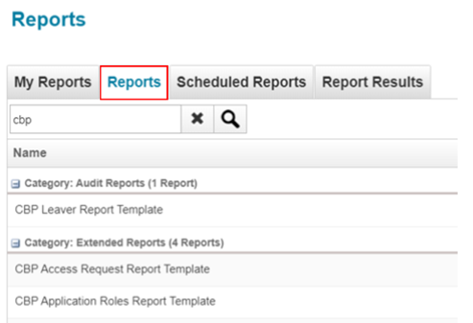

1. In the **Edit Report** screen, you can customize the **Report Properties** including *Standard Properties, Report Settings, and Report Layout.*

In the **Standard Properties**, enter the name of the report in the Name section.

1. Select the **Report Settings** and select anapplication from the **Application** drop-down, then select one or more **Environment** for which the report will be run.
   1. **NOTE:** You can only select one application at a time, but can select multiple environments.

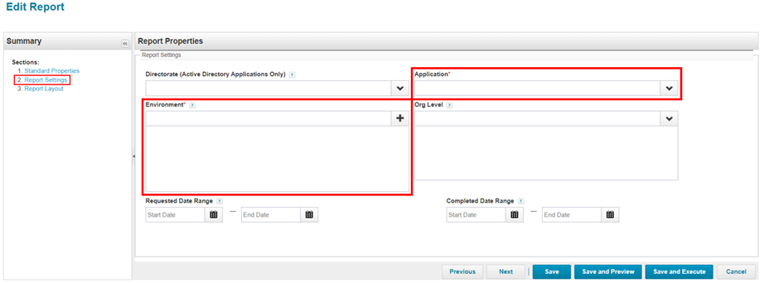

1. Select **Report Layout** and move the columnsthat you want to displayin the report to the right. Then select **Save and Execute** to run the report.

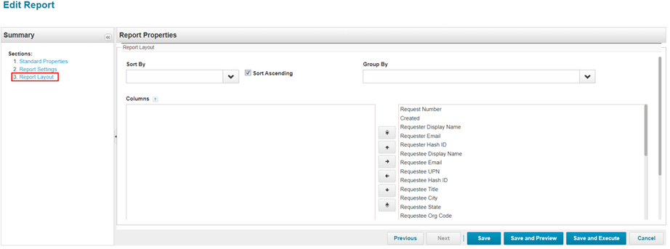

1. Once the report has completed running, select **View Report Results.**

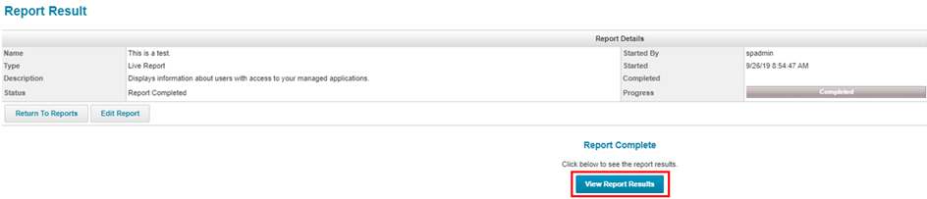

1. The Report Result screen will display a preview of your report results. You can **also Download PDF** or **Download CSV**.

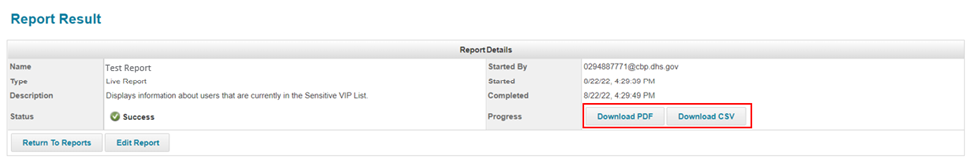

1. Navigate to the **My Reports** tab to view the reports that you have previously run. You can right-click on a report and select **Execute** to run a fresh report. You can also **Delete** reports that you no longer need.

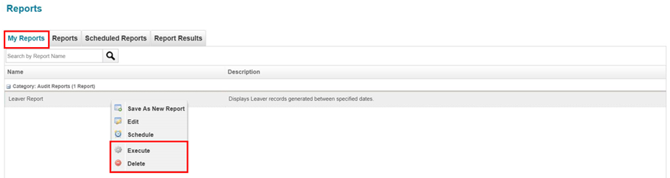

1. In the same tab, you can right click on a report and select **Schedule** to have the report execute again on a specified date/time.

* Enter a Name for the task in the New Schedule form.
* Enter a description to provide context for the repeating report.
* Select the date and time for the first report to run. (Optionally select the “Run Now” box to also run the report immediately)

* The Execution Frequency allows you to set the frequency of the report.

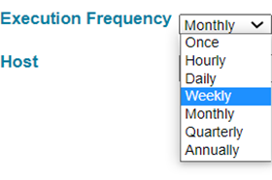

* The Host field is optional and allows you to set the specific server to run the report on, if needed. It is recommended to **leave this field blank** for general use.
* Once the form has been completed, select the schedule button to execute the report.

1. Navigate to the **Report Results** tab to view the report results that you have run. Click on the report name to view the results.

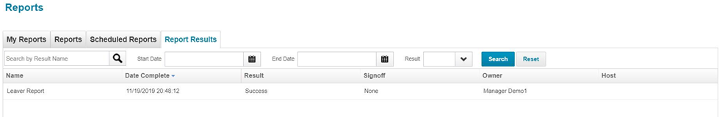

# Troubleshooting

If you require further assistance, please submit a ticket via ServiceNow and set the Service to **CSD ID Management.**

If unable to access ServiceNow, please call TSD to have them submit a ticket with Service set to **CSD ID Management.**

Contact TSD at the following numbers:

* For CBP personnel: Please call, 1-800-927-8729
* For Non-CBP personnel: Please call, 1-866-530-4172